IFTT Directions
Please note that the website for IFTT has been updated since the MyITLab video and directions were created. This is a new short-cut version. Please feel free to view all of the available information in MyITLab to help you understand the “nuts and bolts” of the assignment, or just follow the directions below.
Go to:
https://ifttt.com/
Sign up and create a login and password.
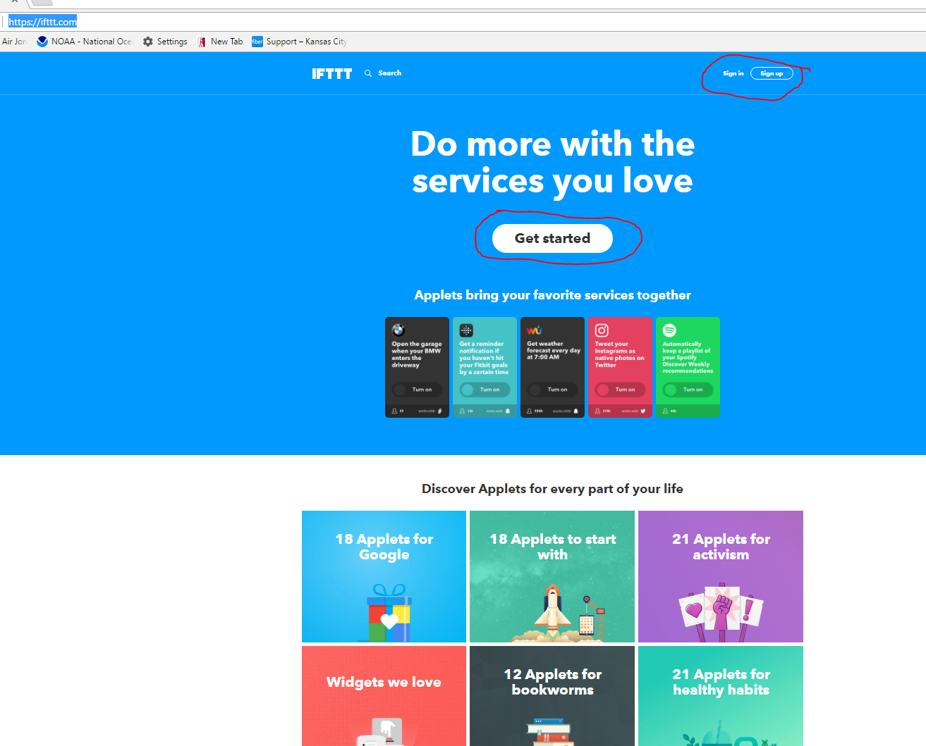

Choose from available applets. Some work with Facebook, e-mail, certain operating systems, appliances, or websites. Please be aware that they will ask to access accounts. Apps that send information to e-mail may be a good choice.
Select an applet that will be useful for you. For instance, don’t choose the coffee making app if you don’t own that particular appliance!

A variety of categories will scroll across the screen. You can choose any one of them, but you might want to view the All Applet collection first. To see what is available.

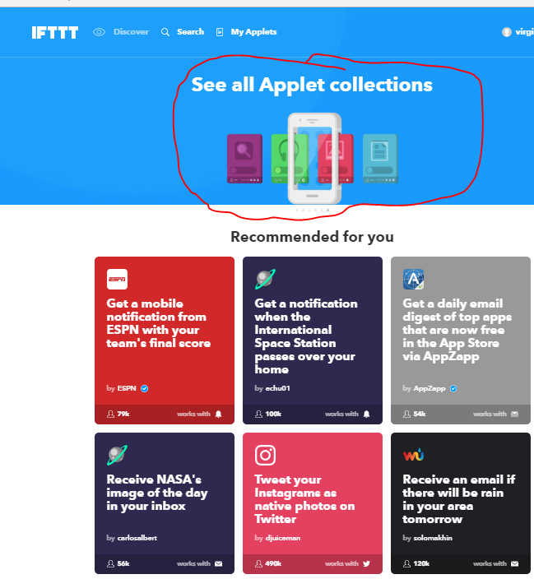

Check out the categories and select one.
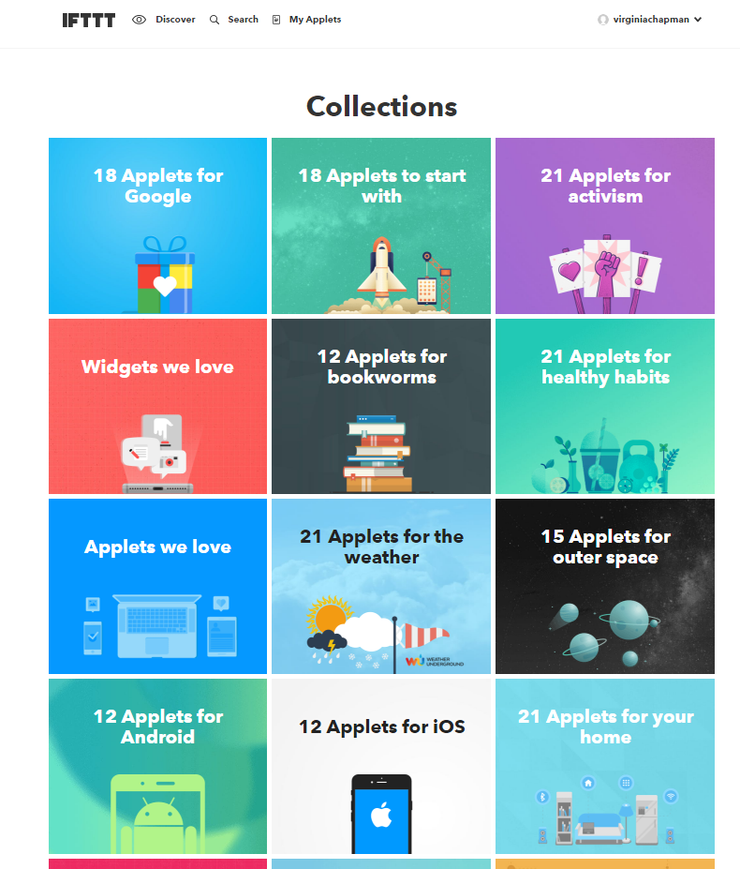

For example, if you choose 12 Applets for Educators, you could select “Automatically get a weekly vocabulary list of Wikipedia words of the day in your e-mail.” You then configure the app to work for you.
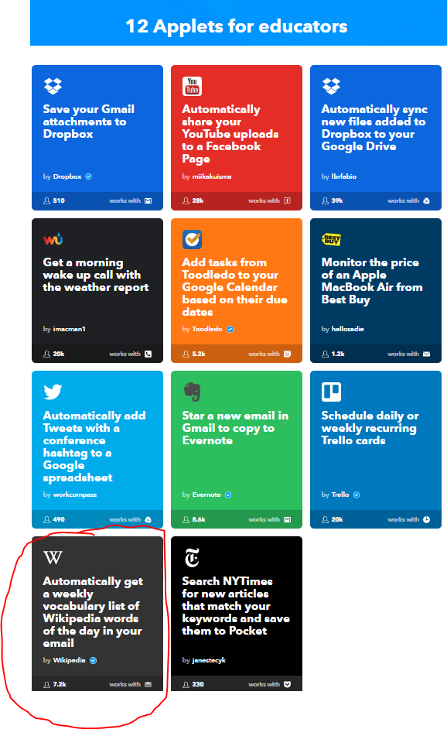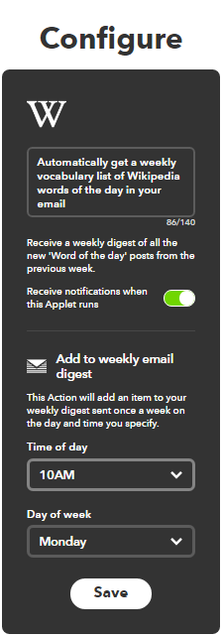

Submit a screen shot of your app to the submit assignment area of our Canvas course.

