Annual Editions Journal Summary

Instructions:  - Summarize each of the readings in the tables below.  - You may expand the table to accommodate your information.  - Write in complete sentences using proper grammar and mechanics.  Readings:  Unit 8 in the textbook: Projecting the Future  - What the Future of Home Automation Can Learn from Back to the Future, Medium, 2015  - To Automate Everything, Solve These Three Challenges, Alison Bruzek, Nova Next/PBS, 2015  - The Murky Ethics of Driverless Cars, Tom Jacobs, Pacific Standard, 2 | 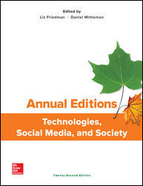

Reading #33 – What the Future of Home Automation Can Learn from Back to the Future
Main idea of the article:

Information presented: List at least five points made by the author

1.
2.
3.
4.
5.

Response to the article:

Reading #34 – To Automate Everything, Solve These Three challenges
Main idea of the article:

Information presented: List at least five points made by the author

1.
2.
3.
4.
5.

Response to the article:

Reading #35– The Murky Ethics of Driverless Cars

Main idea of the article:

Information presented: List at least five points made by the author

1.
2.
3.
4.
5.

Response to the article:

