Annual Editions Journal Summary

Instructions:  - Summarize each of the readings in the tables below.  - You may expand the table to accommodate your information.  - Write in complete sentences using proper grammar and mechanics.  Readings:  Unit 6 in the textbook: IT, Business, and Economy  - Social Capital: The Secret behind Airbnb and Uber, Barbara Gray, Medium, 2014  - Technology Is Changing How We Live, but It Needs to Change How We Work, Ezra Klein, Vox, 2016  - The Mirage of the Marketplace, Tim Hwang and Madeleine Clare Elish, Slate, 2015  - How Technology Is Destroying Jobs, David Rotman, MIT Technology Review, 2013 | 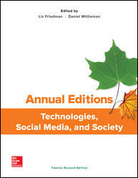

Reading #23 - Social Capital: The Secret behind Airbnb and Uber

Main idea of the article:

Information presented: List at least five points made by the author

1.
2.
3.
4.
5.

Response to the article:

Reading #24 – Technology Is Changing How We Live, but It Needs to Change How We Work
Main idea of the article:

Information presented: List at least five points made by the author

1.
2.
3.
4.
5.

Response to the article:

Reading #25 – The Mirage of the Marketplace
Main idea of the article:

Information presented: List at least five points made by the author

1.
2.
3.
4.
5.

Response to the article:

Reading #26 – How Technology Is Destroying Jobs
Main idea of the article:

Information presented: List at least five points made by the author

1.
2.
3.
4.
5.

Response to the article:

