4.1 Rock Inquiry
A. REFLECT & DISCUSS Describe the rock below, where it may have formed, and how it may have formed.

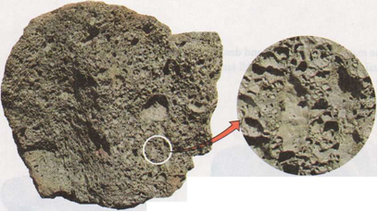

B. REFLECT & DISCUSS Describe the rock below, where it may have formed, and how it may have formed.

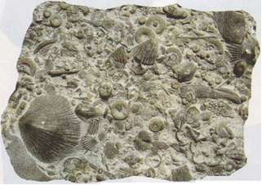

4.2 What Are Rocks Made Of?
A. What is the difference between in situ mineral grains and detrital mineral grains?

B. REFLECT & DISCUSS Rocks are made of the materials listed below and described on page 115. Below each sample, write the name of every kind of material it contains from the list below. Be prepared to compare your observations with the observations of the other geologists.
Mineral grains (in situ) Clasts (detrital minerals) Gravel Silt Glass
Mineral grains (detrital) Clasts (rock fragments) Sand Clay Bioclasts
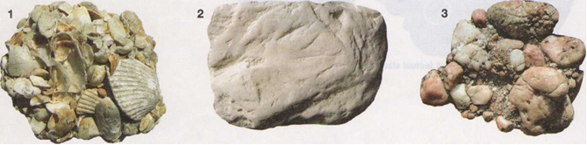
3)

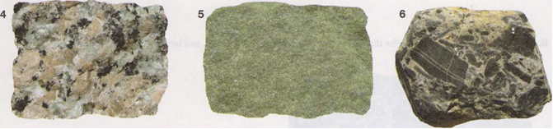
4) | 5) | 6)

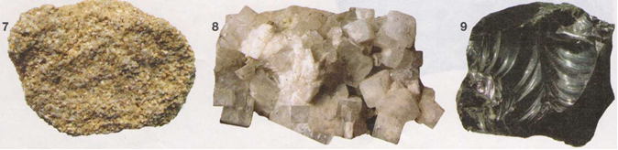
7) | 8) | 9)

4.3 Rock-forming Minerals
A. REFLECT & DISCUSS Refer to FIGURE 4.3 (page 116) and identify each rock-forming mineral below. Write its name below the picture. Be prepared to compare your observations with the observations of the other geologists.
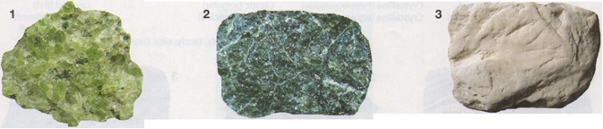
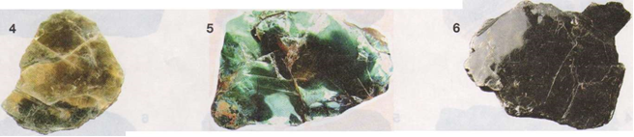
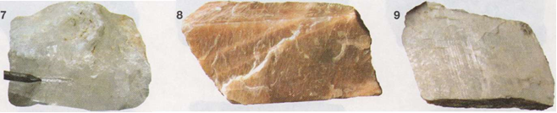
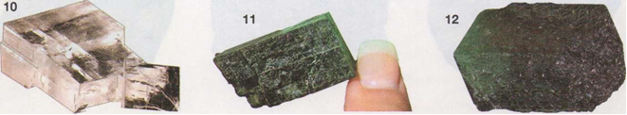
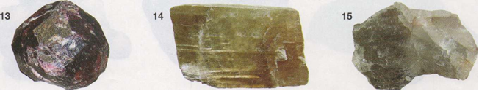

4.4 What Is Rock Texture?
A. Review the following list of textures on page 117. Below each sample, write the name of every one of these textures it contains.
Glassy Fine-grained Crystalline (heterogranular) Clastic (angular) Layered (flat)
Vesicular Coarse-grained Crystalline (equigranular) Clastic (rounded) Layered (foliated)
Bioclastic Layered (folded) Clastic (gravely, sandy, silty, clayey)

B. Reflect & Discus: Based on the texture(s) and composition of each of the rocks in part A, below each sample, write whether you think it is igneous, sedimentary or metamorphic and why?

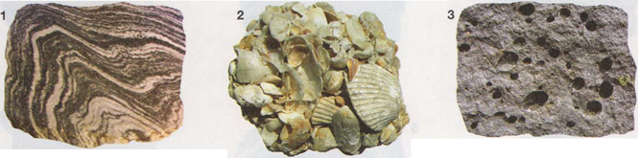
1 | 2 | 3
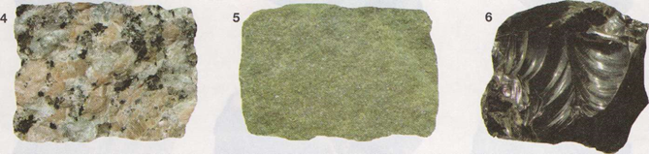
4 | 5 | 6
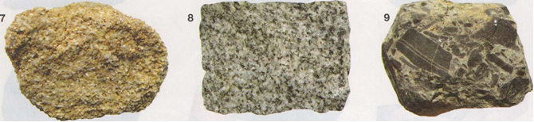
7 | 8 | 9
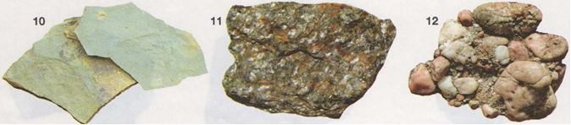
10 | 11 | 12

